Cite Pay USA instructions:
- https://www.citepayusa.com/payments/welcome.do?court=hillJp
- Select “Make a Payment” on the right hand side of the page.
- Use the box on the left hand side of the screen which states “Citation Number”
  - Enter your citation number (Upper right hand side of citation, begin with “D” or “A”)
  - Enter date of birth
  - Check the box to the right of the Charge in which you would like to pay.

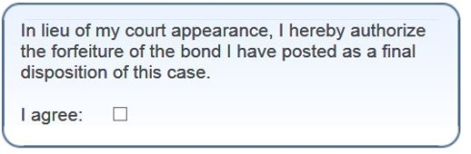
- Be sure to check this box on the left side of the page:

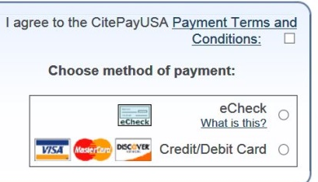
- Select your method of payment on the right hand side of the page:

- Continue with your method of payment. Once finished, the money
comes straight to the Court and will be applied to your case.

